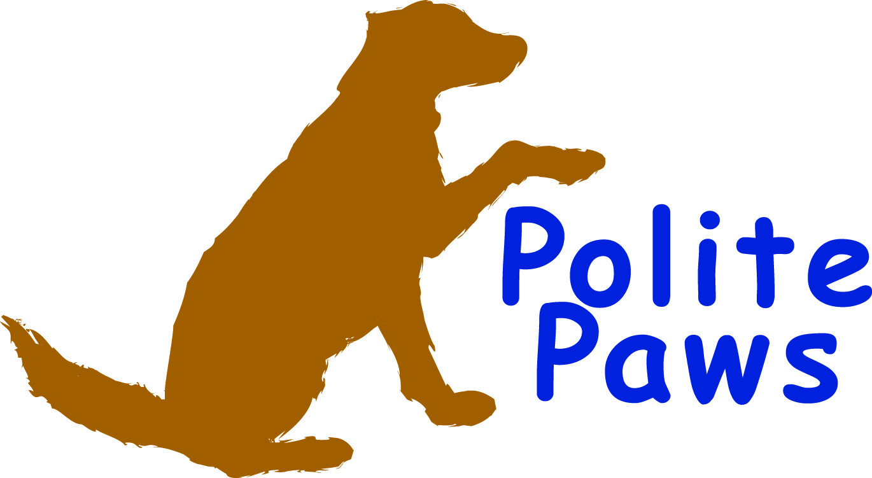LLC
Educated Owners, Respectful Dogs
Shannon Sumner- 610-458-3509
politepaws@comcast.net
www.politepawsdogtraining.com
Doggie Vacation Registration Form

(please type or print)
Owner’s name

Address

Phone (home) Phone (other)
Email

Dog’s name Dominant Breed

Dog’s gender Dog’s age
Dog’s birth date Dog’s weight

Where did you acquire your dog (i.e. shelter, breeder, etc.)
For how long have you had your dog?
Where does the dog stay when you are not home?
Where does your dog sleep at night?
How much food and what brand of food does your dog eat per feeding?
How many times per day (and at what time) does your dog typically eat?
Does your dog take any medication?
If so, what is the name of the medication?
What are the instructions for administering the medication?

****Has your dog EVER shown any signs of aggression?
If so, please describe toward whom (dogs, people, etc.) and what type of aggression (growls, shows teeth, bites, lunges, etc.)

Does your dog have any phobias (i.e. thunderstorms) or exhibit any unusual behavior? If so, please describe:

Please provide your veterinarian’s information below:
Veterinarian hospital or clinic
Name of veterinarian
Address
City State Zip code
Phone number

Liability Release:

Polite Paws, LLC does not assume and shall not be held responsible for any liability with respect to the pet specified on this agreement , of any kind whatsoever, arising out of or from the boarding of this pet, or any damages which may accrue from any other cause whatsoever, including loss by fire, theft, disease, running away, death, injuries to persons, animals or property, or death or injury to any other animal caused by the within named pet on this contract.

Owner is responsible for pet’s veterinary care if it is required while staying at Polite Paws, LLC.

Pet must have identification on while staying at Polite Paws, LLC.
All pets must have a current PA license. Please provide the dog license # here.

All pets must be up-to-date on Distemper, Parvo, and Rabies vaccinations, in accordance with their veterinarian’s requirements, and up-to-date on flea and tick prevention (Frontline, Revolution, etc.). Please provide a copy of the pet’s vaccination records upon the start of your pet’s stay.

Your dog will be kept in whatever crate you provide to Polite Paws, LLC. Please acknowledge that your crate does not meet the Department of Agriculture standards for boarding a dog. By signing here, you accept responsibility for the decision to keep your dog in his/her personal crate rather than in a “boarding kennel” as specified by the Department of Agriculture (see http://www.agriculture.state.pa.us/portal/server.pt/gateway/PTARGS_0_2_24476_10297_0_43/AgWebsite/OrganizationDetail.aspx?name=Bureau-of-Dog-Law-Enforcement&navid=34&parentnavid=0&orgid=9).

Signature of owner date

You certify that your dog has never done harm to any other dogs or people.
Initial

Your signature indicates that all information provided on this form is accurate. It also indicates that you agree to the terms and conditions of this contract. Please do not type your signature.

Signature of owner date

